**ASSISTED PRACTICE (THREAD GROUP PLUGIN IN JMETER)**

Step1: Open Jmeter

Step2: Go to Options in Jmeter -> At the bottom, we will see Plugin manager -> Click on that -> Available Plugins -> Search for Custom Thread Group Plugin -> Install it(select the checkbox) -> Once it has been installed -> Click on “Apply changes and restart jmeter” at the bottom of this window -> Jmeter restarts

Stepping Thread Group:

Step1: Right click on Test Plan -> Add -> Thread(Users) -> jp@gc – Stepping Thread Group

Step2: Right click on Thread Group -> Add -> Sampler -> HTTP request

Step3: In HTTP request , Give “https” as Protocol, Give [www.w3schools.com](http://www.w3schools.com) as Server, Give “/xml/note.xml” as Path

Step4: Right click on Thread Group -> Add -> Listener -> View Results Tree (to see the output) -> Save it and execute

Output:

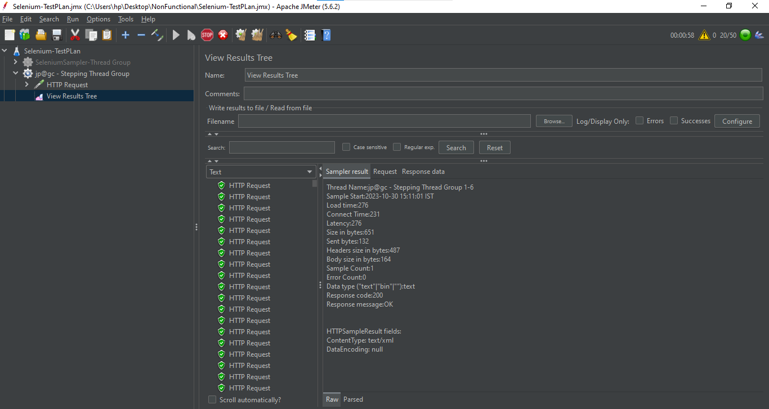

Ultimate Thread Group:

Step1: Right click on Test Plan -> Add -> Thread(Users) -> jp@gc – Ultimate Thread Group

Step2: In Thread Group -> Click on Add row -> Give “10” as Start Threads Count, Give “1” as Initial Delay, sec, Give “3” as Startup Time, sec , Give “60” as Hold Load For, sec, Shutdown Time as blank -> We will see the graph as shown below:

